Eyeconic - Glasses Shop Management System

Use-Case Specification: Edit Sprays

Version <1.0>

Revision History

|  |  |  |  |
| --- | --- | --- | --- |
| **Date** | **Version** | **Description** | **Author** |
| <04/11/2019> | <1.0> | Start creating use case | Nguyễn Tuấn Anh |
|  |  |  |  |
|  |  |  |  |
|  |  |  |  |

Table of Contents

1. Edit Sprays 4

1.1 Brief Description 4

1.2 Basic Flow 4

2.2 Exception 5

2.2.1 Edit Sprays 5

2.2.2 Fill in the Sprays information 5

2. Special Requirements 5

3. Preconditions 5

4. Postconditions 5

5. Extension Points 5

Edit Sprays

# Edit Sprays

## Brief Description

This use case defines the step of update existing Sprays

Sprays are updated by the admin.

## Basic Flow

The system administration selects the Sprays data to edit. The administrator changes the information. The system displays the updated management parameter value and logs the change

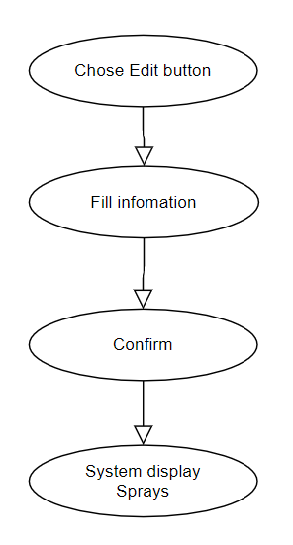

***Basic flow of Editing Sprays***

Step 1: Choose the Sprays you want to edit

Step 2: Click edit button

A modal view shows up

Edit the information.

Step 3: Confirming editing the Sprays by clicking the “Save” button.

Step 4: Successful information changed Sprays are displayed on the screen

## 2.2 Exception

### 2.2.1 Edit Sprays

The edit button cannot be clicked or isn’t appeared on the screen

### 2.2.2 Fill in the Sprays information

Invalid information.

2.2.3 Confirming editing the Spray

The “Save” button is clicked but the new information of the Sprays are not changed.

2.2.4 System displays edited Spray

The edited Spray’ information are not display correctly.

# Special Requirements

# Preconditions

User must already login as the administrator of the website.

# Postconditions

Spray information is changed and can be purchased by customers.

# Extension Points

Administrator check the website and the system to ensure that the edited information of the Sprays is correct.